**EXPERIMENT 8**

**Aim :**

Write a Program to Multiply Two 8-bit Numbers using 8051 Microcontroller.

**Requirements :**

Keil uVision5 Software.

**Procedure :**

1. Open Keil uVision5 software. Click on **project** and select **new uVision project.**
2. Save the project in ASM folder of software directory. A popup window will come up in which we have to **select the device for target,** search **Intel** and select **8051AH** chip and press **ok.**
3. A popup window will come up with message **copy STARTUP.A51 to project folder?** Press **no.**
4. Now click on **new file,** write the program in this file and save it with **.asm extension.**
5. Now on the LHS **Project Window** expand **Target 1** and right click on **Source Group 1** and select **add existing file to group** and select your **.asm** file and click **Add.**
6. Press **F7** to **build target,** check for errors and fix them.
7. Now click on **Start/Stop Debug Session** and press **F5** to start code execution.
8. All the registers and flags are on the upper LHS, code on the upper RHS, command window on lower LHS and memory window on lower RHS.
9. To check the output at RAM memory type **D:location** that is **D:47H** and press enter to observe the result of multiplication.

**Program to Multiply Two 8-bit Numbers :**

|  |  |  |  |
| --- | --- | --- | --- |
| **Address** | **Mnemonics** | **Operands** | **Comments** |
| 0000H | ORG | 00H | Start from Memory Location 00H |
| 0000H | MOV A | 00H | Move 00H to Accumulator |
| 0002H | MOV R2 | #11 | Move 11H Data to R2 Register |
| 0004H | MOV R3 | #07 | Move 07H Data to R3 Register |
| 0006H | HERE **|** ADD A , R2 |  | Add A & R2 Contents and Store in A |
| 0007H | DJNZ R3 , HERE |  | Decrement R3 & Jump to HERE (0006H) if R3 ≠ 0, this will execute R3 times |
| 0009H | MOV | 47H , A | Move the Value of A to RAM Memory Location 47H |
| 000BH | END |  | End of program |

**Screenshots :**

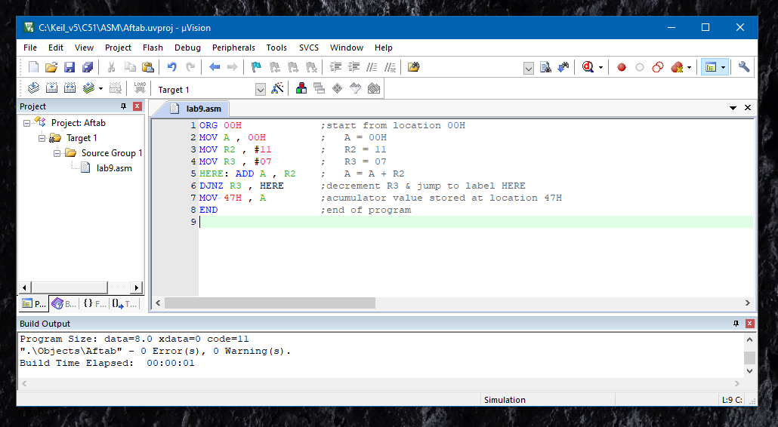

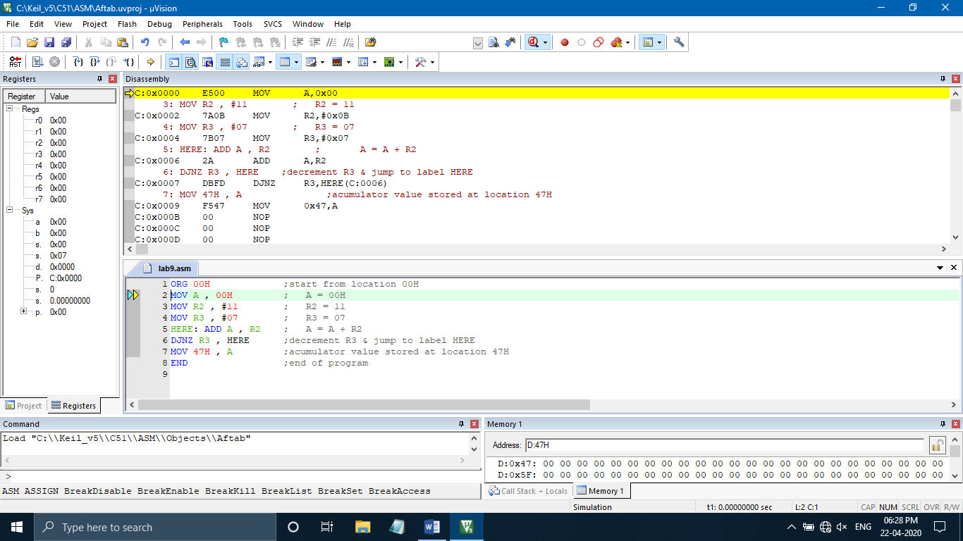

**Flow Chart :**

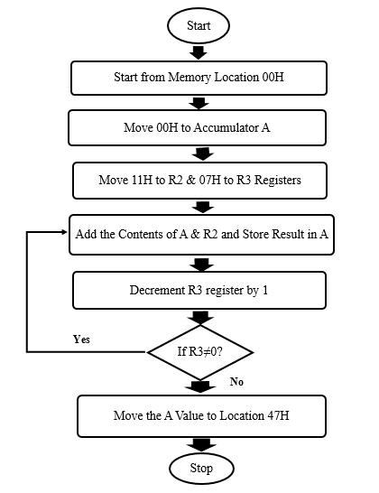

**Output :**

|  |  |
| --- | --- |
| **Before Execution** | |
| **R2 = 11H** | **R3 = 07H** |
| **After Execution** | |
| **Result (at 47H) = 4DH** | |

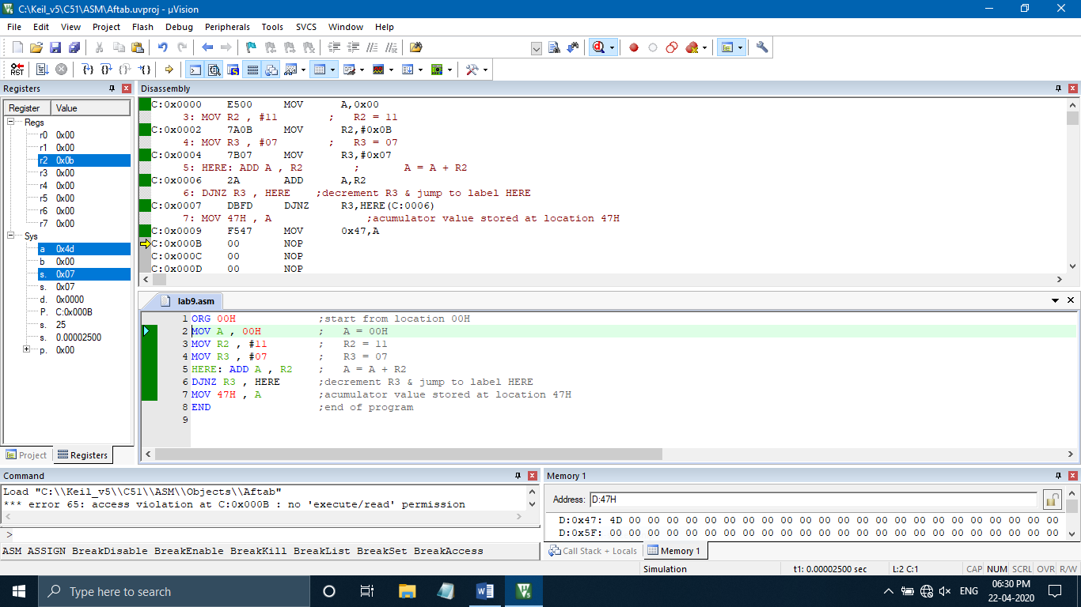

**Result :**

**Yes**

Program to Multiply Two 8-bit Numbers using 8051 Microcontroller was implemented successfully.